Web Development – Creating applications that can be accessible using browser.

Creating Web Pages, Creating Web Sites.

Applications Types

1. Stand-alone Application [Download, Install & Use it – Ex: MS-Office 2010, AutoCAD, NotePad++…] (With or Without Internet Connection we can use this applications)
2. Web Applications [No need to download & install anything, we can directly access it using browser – Ex : Facebook, Gmail, Twitter, Github ]

Apps – Smart Devices (Smart Watch, Smart TV, Smart Phones etc.,)

Tech Stack – Is a way of creating Application using different Lang, framework & tools

* JAVA Full Stack (Java for Back End Coding, JS based framework [Angular/React/Vue] for Front End, any SQL/No-SQL DB for middleware]
* MEAN – MongoDB, Express JS, Angular & Node
* MERN Stack – Mongo DB, Express, React & Node

Operating System : It is a System software which enables the functionality of the Hardware.

Computer – Is an Electronic Device which consist of many parts like CPU, Input & Output Device (Hardwares) – Physical components which can be touch & feel.

Computer = Hardware + Software

Human = Physical Body + Soul

Types of Operating System

1. CUI – Character User Interface [MS-DOS, Unix] (Commands – for creating files, folders, copying, renaming, changing date/time, user mgmt.)
2. GUI – Graphical User Interfaces [Windows, Linux, Mac etc.,] [Everything with clicks]

Unix

**Unix**

Unix is a family of operating systems that derive from one built in the 1970s at Bell Labs by AT&T. The current owner of the Unix license is The Open Group, however, Novell, Inc currently holds the copyrights. Linux operating systems and OS X operating systems are based on Unix. One of Unix's standard features is the command-line shell that is used to interface with the operating system. In Linux, this shell is commonly Bash.

**Bash**

The Bourne Again Shell or Bash is based on the original Unix shell, which was called sh. Bash is compatible with sh and incorporates other features as well. Bash was created in 1989.

Shell or Bash (Shell Script or Bash Script)

Environment (With Respect to Computers) – It’s a Place where all the available software can be accessible.

Operating System (OS) will be saved in either C: drive (For Windows) /root (For Linux & Mac)

Notepad, MS Paint, Clock, Calculator,

Installing third party applications like PhotoShop, Adobe Acrobat Reader

Command Prompt / Power Shell (Windows) [ exe, cmd, bat]

Bash/ Shell (Linux) [rpm, pkg]

Bash/Terminal (Mac) [dmg]

Environment Variables (we can add/edit/delete) using the commands & GUI

Types of Environment Variable

1. User Level (For Currently Logged user only)
2. System Level (For All Users)

# Environment Variables

Environment variables are values that are accessible in an entire working environment. In Unix, these values are set in the shell when it is started. For example, your home directory is an environment variable called $HOME. If you wish to see the value of a particular environment variable, you can use the echo command like so: echo $HOME.

To set your own environment variables, you can use the export command. For example, if you wanted to create an environment variable to store the password to your server, you could issue the following:

export SERVER_PASS=password

echo $SERVER_PASS

However, if you issue the above command into your console, when you close the shell and open it again, your environment will no longer be present. To keep these environment variables, you will have to place the command in one of your startup files, usually

~/.bashrc

You can also remove environment variables with the unset command:

unset SERVER_PASS

echo $SERVER_PASS

## Practical Uses

So, what's the point of having environment variables? They have several different uses that we can discuss.

### PATH

The PATH variable is one of the most commonly used environment variables, and it typically already exists on your computer. The reason for this is that it is used to reference the locations of software installations on your machine, especially software that requires certain commands that can be used in the terminal. For example, when you install Git, your machine needs to know where it is installed so that when you try to run a git command, it knows what code it's supposed to run. Usually this variable is set automatically when you install these kinds of software, but occasionally you need to update or change it yourself, in which case it's important to be aware that it exists and how to do so.

### Server Secrets

Environment variables are a common place to store things like database connection info, credentials, and tokens. When running code on a server, that code may need this information to run, and having the code reference environment variables rather than storing this information directly in the code or in a file makes it easier to modify the variables easily as needed and prevent situations like accidentally pushing credentials to a public Git repository. This makes them slightly safer because that information doesn't risk leaving the computer that the environment variables are on - however, they are still relatively easy to access, so you should be careful not to store sensitive, unencrypted data this way in a production environment.

## On Windows

If you need to work with environment variables on Windows, you can either do so using PowerShell or editing them via settings.

Using Git – We can run unix commands in windows

<https://git-scm.com/downloads>

<https://www.cs.cmu.edu/~213/recitations/fwunixref.pdf>

Setting JAVA_HOME environment Variable

1. In Windows
2. Type “env” in the search box to get “Edit the System Environment Variables” option as shown below.

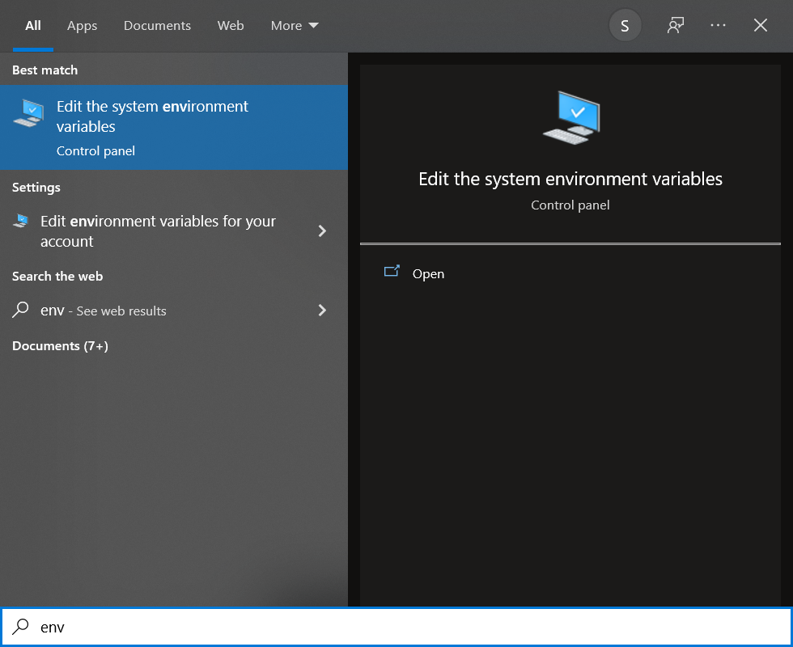

1. Click “Environment Variables” button in the System Settings window.

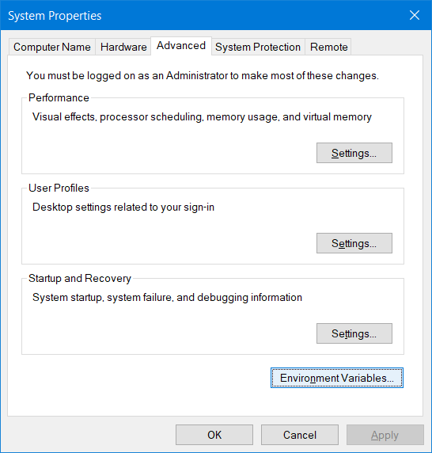

1. Click on “New” button in the System variables section

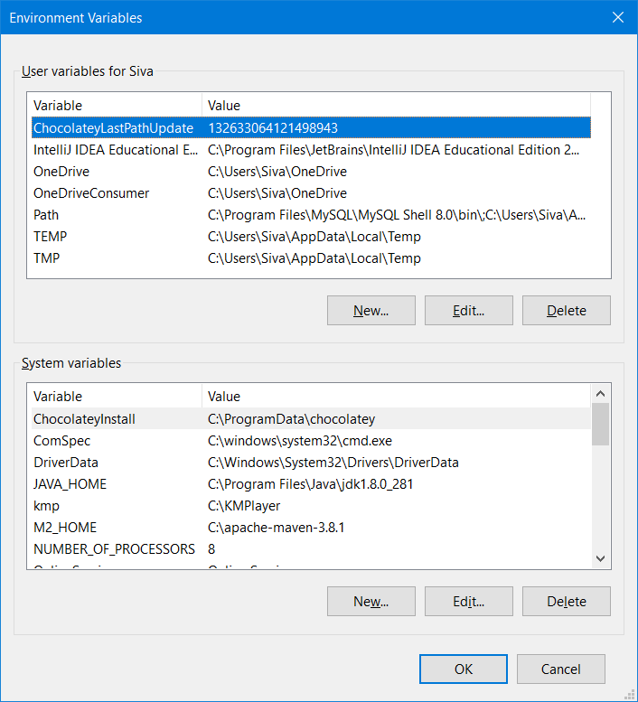

1. Enter the “environment variable” name as “JAVA_HOME” and click the Browse button to select the Jdk installation folder

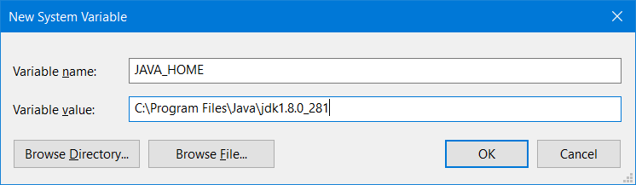

1. Click “Ok” button 3 times.
2. Click the “Environment Variables” button again then select “Path” in “System variables” section and click on “Edit” button

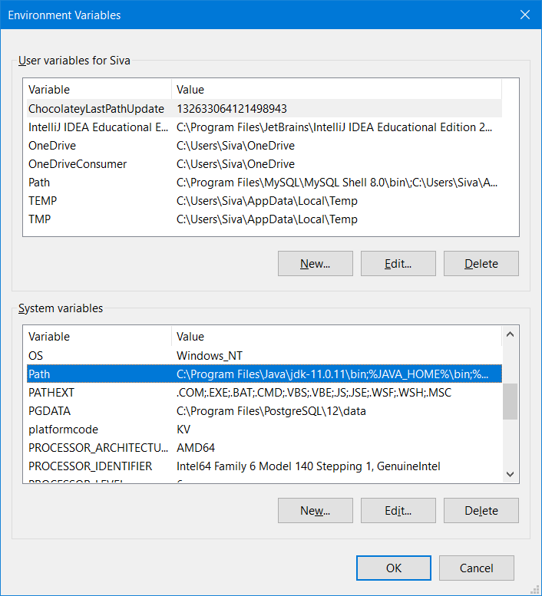

1. Add “%JAVA_HOME%\bin” and move this entry to the top
2. In Mac OS
3. Execute the following command on Mac Terminal:

/usr/libexec/java_home -V

1. It will show you all the versions of JDK installed in your Mac.
2. Now, let's say it shows you paths like as given below:

/Library/Java/JavaVirtualMachines/jdk-14.0.1.jdk/Contents/Home

1. Execute the following command:

cd /Library/Java/JavaVirtualMachines/

ls

pwd == print current /working directory

|  |  |  |
| --- | --- | --- |
| **Sl No** | **User Level Env Variable** | **System Level Env Variable** |
| 1 | This is for currently logged in User only | For all the users using that System |
| 2 | When we are public System | When we use our own personal System |
| 3 | When you don’t have Admin Access | When you have admin access |
| 4 | Sharing application with other users is not possible | Sharing application with other users is possible |

JAVA 8 is the First Major Changes (Lambda, Streams, Functional Programming)

Most of the companies still use Java 8.

OS Types

1. Multi -User OS (More than one user can able to use a single System)
2. Multi-Tasking OS ( Running Multiple applications at the same time)

WSL = Windows SubSystem for Linux

Linux is a GUI (Multi User, Multi Tasking, Multi Purpose Operating System which is highly secured)

Linux kernel is developed by Linus Torvalds

<https://www.cygwin.com/>

|  |  |  |  |
| --- | --- | --- | --- |
| Sl No | Task | In DOS | In Unix |
| 1 | Create a File | Copy con <file_name> | Touch <file_name> or cat > file_name |
| 2 | Editing a file | Edit <file_name> | Touch <file_name> |
| 3 | List files & Folders | Dir | ls |
| 4 | Change to directory | Cd <dir_name> | Cd <dir_name> |
| 5 | Create a directory | Mkdir/md <dir_name> | Mkdir <dir_name> |
| 6 | Remove a directory | Rd <dir_name> | Rm -r <dir_name> |
| 7 | View file contents | Type <file_name> | Cat <file_name> |
|  |  |  |  |

<https://www.guru99.com/must-know-linux-commands.html>